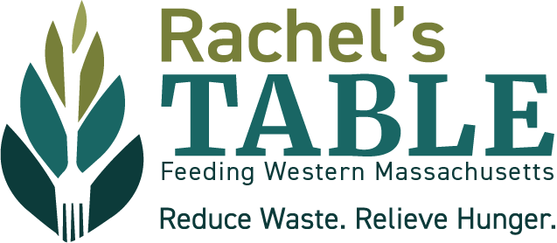

**Title:** Teen Gardening Associate

### **Purpose:** To assist with garden work at various Springfield Growing Gardens partner agencies, contributing to the upkeep and success of these community gardens while earning volunteer hours. To learn more about the Rachels Table of Western Mass Growing Gardens Program, [click here](https://feedwma.org/growing-gardens/). For questions, contact Sarah at [sbate@feedwma.org](mailto:sbate@feedwma.org).

### **Days and Hours Needed**

* **Proposed Dates**: July 1st - August 20th
* **Duration**: 7-8 weeks
* **Hours per Week**: 1-2 hours, 1-2 times a week
* **Commitment**: Need to commit to attending most dates, with allowance for **1 sick day** and flexibility around work or summer vacations.
* **Exact Times**: To be worked out with the garden supervisor.

### **Tasks**

* Weeding
* Harvesting
* Watering
* General garden upkeep

### **Supervisor:** Each participant will have joint supervision by Sarah, Teen Board Coordinator and a garden supervisor/contact person from one of RTWM local growing gardens partner agencies.

### **Types of Training Provided**

* On-site orientation and training specific to the garden's needs
* Supervision and guidance from garden supervisor

### **Transferable Skills**

* Interest in gardening and horticulture (previous knowledge is a plus, but not required)
* Teamwork and collaboration
* Time management
* Responsibility and commitment
* Problem-solving skills

### **A successful associate will...**

* Regularly attend and commit to the agreed schedule
* Effectively complete assigned garden tasks
* Positively collaborate with garden supervisors and other volunteers
* Demonstrate learning and application of gardening skills

**Work Environment**

* An associate needs to provide their own transportation to and from the garden sites
* An associate needs to be aware of risks when working outside and arrive with appropriate sun and weather protection. Garden supplies and tools will be provided.
* An associate may need to be available to work early mornings to late afternoons (this varies depending on the type of garden work needed)

**To apply** email [sbate@feedwma.org](mailto:sbate@feedwma.org) with a paragraph expressing interested with related work or study experience, reason why you are interested, and the contact information for one work related reference by July 1st or until position is filled.

Rachel’s Table of Western Massachusetts welcomes the participation of all faiths, people of all abilities, backgrounds and sexual orientations. We are an Equal Opportunity Employer.

**Rachel’s Table:** Rachel’s Table of Western Massachusetts (RTWM) is a grassroot, volunteer-driven hunger alleviation organization. RTWM was founded as the food rescue and recovery program of the Jewish Federation of Western Mass in 1992 and became an independent non-profit in July 2023. Head to feedwma.org to learn more about Rachel’s Table.

**Rachel’s Table Teen Board**: The Rachel’s Table Teen Board’s goal is to support the organization in alleviating hunger and reducing waste of food resources in Western Massachusetts. Partially sponsored by a grant from The Harold Grinspoon Foundation, the Rachel’s Table Teen Board focuses on alleviating childhood hunger and educating their peers about local hunger and poverty issues, and then involving them in being part of the solution. For more information on the teen board and the work they do, visit @rachelstableteens on Instagram, feedwma.org/teen-board or email the teen board director, Sarah Bate, at [sbate@feedwma.org.](mailto:sbate@feedwma.org)