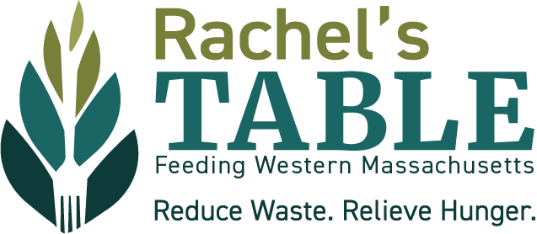

**Title:** Teen Research Associate

### **Purpose:** To research local hunger statistics, specifically focusing on children, and to create curriculum for the upcoming Hunger Awareness Artsfest 2025: Teen Art Competition and Education Initiative. For questions, contact Sarah at [sbate@feedwma.org](mailto:sbate@feedwma.org)

### **Days and Hours Needed:**

* **Proposed Duration**: Over a two-month period, between 6-8 weeks
* **Hours**: Minimum of 15 hours of research
* **Schedule**: Associates can create their own hours, but must meet deadlines and log hours.
* **Supervision Meetings**: Regular check-ins to be scheduled with the Teen Board Coordinator.

### **Tasks:**

* Conducting independent research on local hunger statistics
* Identifying credible sources
* Co-creating educational curriculum based on research findings

### **Supervisor:** Sarah, Teen Board Coordinator

### **Transferable Skills and Core Competencies**

* Research and analytical skills
* Time management and self-discipline
* Creativity in educational curriculum design
* Ability to meet deadlines
* Critical thinking
* Open communication with supervisor and responsive to feedback
* Reliable
* Collaborative

### **Types of Training Provided**

* Initial orientation and guidance from the Teen Board Coordinator
* Ongoing supervision and feedback during regular check-ins

### **A successful associate will...**

* Complete of a minimum of 15 hours of research
* Work independently and meet deadlines
* Identify and use credible sources in research
* Co-create an educational curriculum for Hunger Awareness Artsfest 2025
* Regularly log hours and participate in supervision meetings

### **Stipend:** A stipend of $225 is available upon successful completion of the assignment.

**Work environment**

* Associates are required to have their own personal computer or dedicated access to a computer
* Associates need a working email address and phone number

**To apply** email [sbate@feedwma.org](mailto:sbate@feedwma.org) with a letter (2-page limit) expressing interested with related work or study experience, reason why you are interested, and the contact information for one work related reference by July 1st or until position is filled.

Rachel’s Table of Western Massachusetts welcomes the participation of all faiths, people of all abilities, backgrounds and sexual orientations. We are an Equal Opportunity Employer.

**Rachel’s Table:** Rachel’s Table of Western Massachusetts (RTWM) is a grassroot, volunteer-driven hunger alleviation organization. RTWM was founded as the food rescue and recovery program of the Jewish Federation of Western Mass in 1992 and became an independent non-profit in July 2023. Head to feedwma.org to learn more about Rachel’s Table.

**Rachel’s Table Teen Board**: The Rachel’s Table Teen Board’s goal is to support the organization in alleviating hunger and reducing waste of food resources in Western Massachusetts. Partially sponsored by a grant from The Harold Grinspoon Foundation, the Rachel’s Table Teen Board focuses on alleviating childhood hunger and educating their peers about local hunger and poverty issues, and then involving them in being part of the solution. For more information on the teen board and the work they do, visit @rachelstableteens on Instagram, feedwma.org/teen-board or email the teen board director, Sarah Bate, at [sbate@feedwma.org.](mailto:sbate@feedwma.org)